

Variable Term Agreement (VTA)
Wholesale Special and Switched Access
DS1 and DS3

21 States
Guide
June 29, 2018

TABLE OF CONTENTS
LIST OF FIGURES AND TABLES 2
1 REVISIONS 2
2 PURPOSE 3
3 TARIFF REFERENCES 4
3.1 DS1 TARIFF REFERENCES 4
3.2 DS3 TARIFF REFERENCES 5
4 ESTABLISHED/EXISTING CIRCUITS: COMMON RULES 6
4.1 Moves and Service Rearrangements (including Rollovers) 6
4.2 Adding Term to an established/existing circuit 6
4.3 Removing Term from an established/existing circuit 6
5 RETERM 7
5.1 AT&T 12-STATE REGIONS 7
5.2 AT&T 9-STATE REGION 7
6 VTA Regional Formats and ASR Field Use 8
6.1 AT&T MIDWEST REGION (IL, WI, OH, IN, MI) 8
6.1.1 VTA field 8
6.1.2 PNUM field 8
6.1.3 PSD field 8
6.1.4 ASR Example 9
6.2 AT&T SOUTHEAST REGION (TN, AL, KY, MS, LA, NC, SC, FL, GA) 10
6.2.1 VTA field 10
6.2.2 PNUM field 11
6.2.3 PSD field 11
6.2.4 ASR Example 11
6.3 AT&T SOUTHWEST REGION (AR, KS, MO, TX, OK) 12
6.3.1 VTA field 12
6.3.2 PNUM field 13
6.3.3 PSD field 13
6.3.4 ASR Example 13
6.4 AT&T WEST REGION (NV & CA) 14
6.4.1 VTA field 14
6.4.2 PNUM field 15
6.4.3 PSD field 15
6.4.4 ASR Example 15
7 AT&T VTA FORMAT GUIDE: ONE PAGE SUMMARY 0

LIST OF FIGURES AND TABLES

Figure 1: AT&T Midwest VTA Field Example 8
Figure 2: AT&T Midwest PNUM Field Example 8
Figure 3: AT&T Midwest ASR Example 8
Figure 4: AT&T Southeast VTA Field Example-DS1 9
Figure 5: AT&T Southeast VTA Field Example-DS3 9
Figure 6: AT&T Southeast PNUM Field Example 10
Figure 7: AT&T Southeast ASR Example 10
Figure 8: AT&T Southwest VTA Field Example 11
Figure 9: AT&T Southwest PNUM Field Example 12
Figure 10: AT&T Southwest ASR Example 12
Figure 11: AT&T West VTA Field Example 13
Figure 12: AT&T West PNUM Field Example 14
Figure 13: AT&T West ASR Example 14
Table 1: DS1 Tariff References 4
Table 2: DS3 Tariff References 4
Table 3: AT&T VTA Format Guide Summary 15

1 REVISIONS
Issue number | Date | Description | Published by
1 | 05/31/2013 | Initial release (Trail/Draft) | BR9557, DP5238, JD9127
2 | 06/30/2014 | Finalized and released | BR9557 (document owner), DP5238, JD9127
3 | 05/04/2015 | Section 6.3 Updated SE grandfathered plans per Tariff Filing 5/1/2015 | BR9557
4 | 6/29/18 | Sections refering to East region deleted | AH762A
5 | 6/29/18 | Section 6.1; 6.2; 6.4 Updated grandfathered term plans | AH762A

2 PURPOSE
The primary focus of this document is on Wholesale Special and Switched Access DS1 and DS3 services. The purpose of this document is to provide AT&T’s Wholesale Access Customers guidance for ordering services under various term plans within each AT&T region. The Access Service Ordering Guide (“ASOG”) refers to such plans as “Variable Term Agreements” or “VTA.”
This document is provided for the convenience of Customers in ordering access services. Nothing in this document modifies any of the provisions of any applicable service tariff. For a complete description of the rates, terms, and conditions applicable to any of the services, consult the relevant tariff(s).
AT&T reserves the right to modify or cancel any of the information herein. AT&T shall incur no liability to any carrier if the information set forth herein is modified or cancelled by AT&T.

3 TARIFF REFERENCES

3.1 DS1 TARIFF REFERENCES

Table 1: DS1 Tariff References
DS1 | Midwest  (IL,WI,OH, MI) | Southeast  (TN, AL, KY, MS, LA, NC, SC, FL, GA) | Southwest  (AR, KS, MO, TX, OK) | West  (NV, CA)
Available Term Options | MTM | MTM | MTM | MTM
Available Term Options | Optional Payment Plan (OPP): | Channel Service Payment Plan (CSPP): | Optional Payment Plan (OPP): | Optional Payment Plan (OPP):
Available Term Options | - 1, 2 and 3 Year Terms | - Plan A: 24-36 months | - 1, 2 and 3 Year Terms | - 1, 2 and 3 Year Terms
Rates | FCC 2 Tariff | FCC 1 Tariff | FCC 73 Tariff | FCC 1 Tariff
Rates | - Price Cap Sect.7.5.9 | - Price Cap Sect. 7.5.9 | - Price Cap Sect. 7.3.10 | - (CA) Price Cap Sect. 7.5.9
Rates | - MSA Sect. 21.5.2.6.1 | - MSA Sect. 23.5.2.9.1 | - MSA Sect. 39.5.2.7.1 | - (CA) MSA Sect. 31.5.2.7.1
 |  |  |  | - (NV) Price Cap Sect. 7.11.5.3
 |  |  |  | - (NV) MSA Sect. 22.5.2.6.1
Upgrade Terms | FCC 1 Section 7.4.10 (D) | FCC1 Section 2.4.8 (A)  (4) (b) | SWBT FCC73 Section  7.2.22 (B) | NB FCC1 Section  7.11.5.2 (B)
Upgrade Terms | FCC # 1 Section 7.4.13 (F) | FCC1 Section 2.4.8 (A)  (4) (b) | SWBT FCC73 Section  7.2.22 (B) | PB FCC1 Section  7.4.18 (B)
Move Policy | See Ameritech  FCC#2 Section  7.4.10 (E) (i) | FCC1 Section 2.4.8 A (5) ( c ) | Southwestern Bell FCC #73 Section 7.2.22 (C) | PacBell FCC#1 Section 7.4.18 (C)
Nevada Bell FCC #1
Section 7.11.5.2 (C)
Term Liability | FCC2 Section  7.4.10 C | FCC1 Section 7.4.16 (A) | SWBT FCC#73  Section 7.2.22 (G) | NB FCC#1 Section  7.11.5.2 (G)
PB FCC#1 Section
7.4.18 (G)
Price Flex | FCC2 Section 22 | FCC1 Section 25 | FCC73 Section 41 | NB FCC1 Section 23
 |  |  |  | PB FCC1 Section 33

3.2 DS3 TARIFF REFERENCES

DS3 | Midwest  (IL,WI,OH, MI) | Southeast  (TN, AL, KY, MS, LA, NC, SC, FL, GA) | Southwest  (AR, KS, MO, TX, OK) | West  (NV, CA)
Available Term Options | DS3 Optional Payment Plan | LightGate DS3 Service | Megalink Custom  Service | Fiber Advantage DS3 Rate Stability Payment Plan (RSPP)
Available Term Options | - 1, 2 and 3 Year Terms and Monthly Extension Rates when term plan expires | - MTM | - 1, 2 and 3 Year Terms and Monthly Extension Rates when term plan expires | - 1, 2 and 3 Year Terms and Monthly Extension Rates when term plan expires
Available Term Options |  | - Transport Payment Plan (TPP)  Plan A = 12 – 36 months
Rates | FCC 2 Tariff | FCC 1 Tariff | FCC 73 Tariff | FCC 1 Tariff
Rates | - Price Cap Sect.7.5.9 | - Price Cap Sect. 7.5.9 | - Price Cap Sect. 20.5 | - (CA) Price Cap Sect. 7.5.9
Rates | - MSA Sect. 21.5.2.6.1 | - MSA Sect. 23.5.2.9.1 | - MSA Sect. 39.5.2.12.1 | - (CA) MSA Sect. 31.5.2.7.1
 |  |  |  | - (NV) Price Cap Sect. 7.11.5.3
 |  |  |  | - (NV) MSA Sect. 22.5.2.6.1
Upgrade Terms | OPP: Section 7.4.10 (D) | FCC1 Section 2.4.8 (D)  (4) (c ) | FCC73 Section 20.4.6 | For PacBell see FCC1 Section 7.4.11 (E)
Move Policy | Section 7.4.10 (E) | FCC1 Section 2.4.8 D (5) | Southwestern Bell FCC #73 Section 20.4 Portability | PacBell FCC#1 Section 5.2.9 (C)
Nevada Bell FCC #1
Section 7.2.3
Term Liability | FCC2 Section  7.4.10 C | FCC1 Section 2.4.8 (D) (4) | FCC73 Section 20.4.6 | NB FCC1 Section  7.11.5.1 (B)
PB FCC#1 Section
7.4.18 (G)
PB FCC1 Section
7.4.11 (B)
PB FCC1 Section
7.4.11 (F)
PB FCC1 Sect. 7.4.11
(C) (2)
Price Flex | FCC2 Section 22 | FCC1 Section 25 | FCC73 Section 41 | NB FCC1 Section 23
 |  |  |  | PB FCC1 Section 33

4 ESTABLISHED/EXISTING CIRCUITS: COMMON RULES

4.1 Moves and Service Rearrangements (including Rollovers)
- Service rearrangements including rollovers typically will not require a new VTA.
- Moves:
  - A move involves a change in the physical location of one of the following:
    - The Point of Termination at the customer's premises
    - The customer's premises
  - If the circuit’s physical address (customer’s premises or point of termination at customer’s premises) does not change, the VTA will remain the same.
  - If the circuit’s physical address (customer’s premises or point of termination at the customer’s premises) changes, the VTA will change except for qualifying moves associated with DS1 Special Access term plans in the Midwest, Southwest, and West—see applicable tariffs.

4.2 Adding Term to an established/existing circuit
- Add Term with a Record activity ASR.
- Term starts from the VTA established date (record ASR due date).

4.3 Removing Term from an established/existing circuit
- Cannot remove term without disconnecting the circuit.
- Term Liability charges will be applied as outlined in the tariff.

5 RETERM
The following processes are limited to Special and Switched Access DS1 and DS3 services.

Price Flex contracts have unique terms and conditions; please contact the AT&T Account Manager for Price Flex contract changes.

5.1 AT&T 12-STATE REGIONS
MIDWEST (IL, IN, MI, OH, WI)
SOUTHWEST (AR, KS, MO, OK, TX)
WEST (CA, NV)

The Variable Term Agreement (VTA) reterm process allows customers to reterm circuits based on the following ASR criteria:
- REQTYP = SD
- ACT = R
- PROJ Field = RETERM
- VTA Field must be populated.
- If the PROJ Field entry is not RETERM, the reterm process will not be implemented on the ASR request.
- For Southwest and West regions, the Record ASR DDD must match the contract date DDD to ensure it is renewed on the correct date and does not fall delinquent.

5.2 AT&T 9-STATE REGION
SOUTHEAST (TN, AL, KY, MS, LA, NC, SC, FL, GA)

Reterm option via an ASR is not available.
- Customers must contact their account team to request a new contract period.

6 VTA Regional Formats and ASR Field Use

6.1 AT&T MIDWEST REGION (IL, WI, OH, IN, MI)
The VTA format is based on the amount of months desired.

6.1.1 VTA field: The format is XX (xx = number of months).
- All DS3s require the VTA field to be populated.
- For DS1 service, populate the VTA field with the number of months desired; otherwise, leave the VTA field blank only if ordering service on a month-to-month basis.

- Options for Optional Payment Plan (OPP) DS1 & DS3 are:*
  - 12 = 12 months
  - 24 = 24 months
  - 36 = 36 months
  - 48 = 48 months**
  - 60 = 60 months**
  - DS1 only: Month-to-Month (MTM), leave VTA field blank.
  - *If PNUM is populated, non-standard terms are allowed based on Price Flex contract. Consult the AT&T Account Manager for additional information on Price Flex contracts.

VTA # of term months
Field
Example: 36

Figure 1: AT&T Midwest VTA Field Example
- Discount Commitment Program (DCP):
  - Contact the AT&T Account Manager for more information.

**NOTE: Effective September 2017, grandfathered Interstate Special Access DS1 and DS3 term payment and portability plans with terms longer than 3 years.

6.1.2 PNUM field: example = PF222xxx (xxx = unique contract number)
- If PriceFlex does not apply, leave PNUM blank.

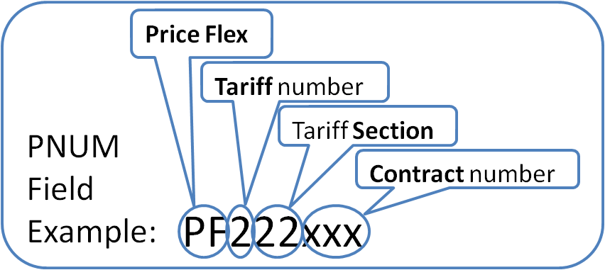
Figure 2: AT&T Midwest PNUM Field Example
6.1.3 PSD field: no longer used

6.1.4 ASR Example: Customer desires term of 36 months with a Price Flex contract.

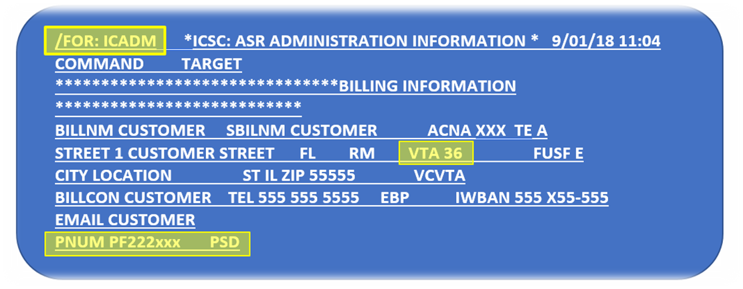
Figure 3: AT&T Midwest ASR Example

6.2 AT&T SOUTHEAST REGION (TN, AL, KY, MS, LA, NC, SC, FL, GA)
The VTA format is based the payment plan and the amount of months desired.

- The common payment plans offered are:*
  - Month-to-Month (MTM)
  - CSPP:
    - 24 months to 48 months***
    - 49 months to 72 months***
    - 73 months to 96 months (not valid for DS1) **
  - TPP:
    - 12 months to 36 months
    - 37 months to 60 months***
    - 61 months to 96 months**
  - ACP:
    - Not ordered at the circuit level; elements covered under ACP must be billed at the Month-to-Month rate.
    - Regional ACP service periods mirror the CSPP plan A and B.

*Service-specific configurations payment plans may differ—refer to tariff for plan requirements
**NOTE : Effective 5-15-15, Grandfathered terms are as follow: CSPP Plan C term length of 74 to 96 months, TPP Plan C term length of 62 to 96 months, and ACP Plan B term length of 61 to 72 months. These changes apply to new CSPP, TPP and/or ACP plans. There will be no change to existing CSPP, TPP or ACP subscriber plans.

***NOTE: Effective September 2017, grandfathered Interstate Special Access DS1 and DS3 term payment and portability plans with terms longer than 3 years.

6.2.1 VTA field: The format should be as follows: example = Axx (xx = number of months).
- Populate the payment plan (1 or A) and the number of months being requested
  - DS1:
    - Transport Payment Plan (TPP) only:
      - Axx (xx = the number of months from 12 to 36)
    - Channel Service Payment Plan (CSPP) only:
      - 1xx (xx = the number of months from 24 to 36)
    - TPP and CSPP:
      - Axx (xx = the number of months from 24 to 36)
        - Populate CSPP in the ASR “Remarks” with 1xx (xx = the number of months from 24 to 36)—Matching number of months (Axx & 1xx)
    - Month-to-Month (MTM), leave VTA field blank

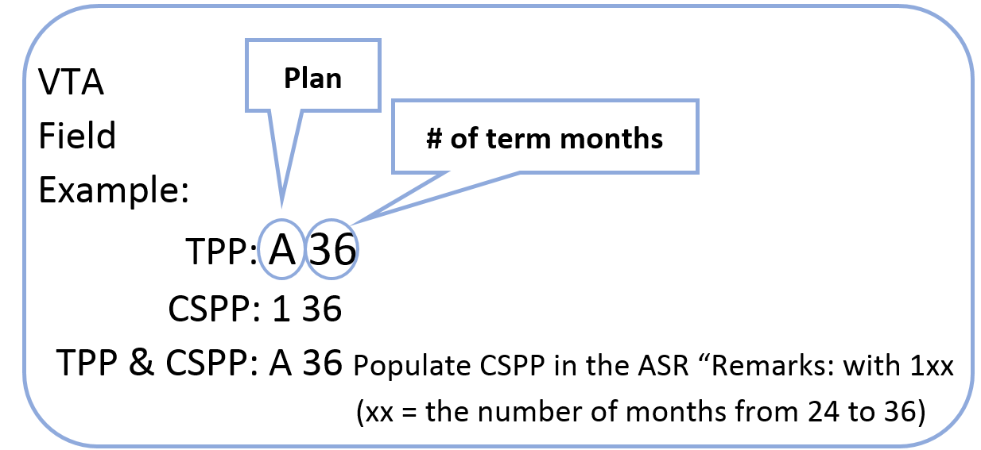

Figure 4: AT&T Southeast VTA Field Example-DS1

  - DS3:
    - Transport Payment Plan (TPP)
      - Axx (xx = the number of months from 12 to 36)
    - Month-to-Month (MTM), leave VTA field blank

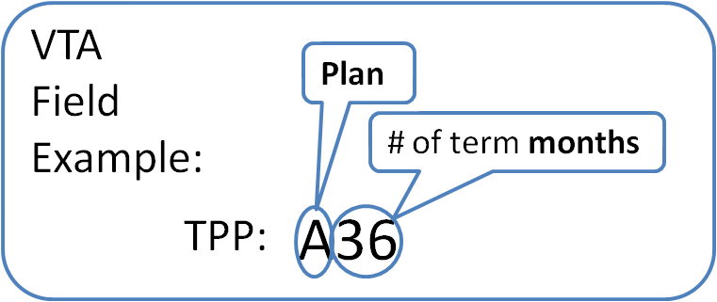
Figure 5: AT&T Southeast VTA Field Example-DS3
6.2.2 PNUM field: example = *PNUM field varies; contact the AT&T Account Manager for specific PNUM requirements
- If PriceFlex does not apply, leave PNUM blank.

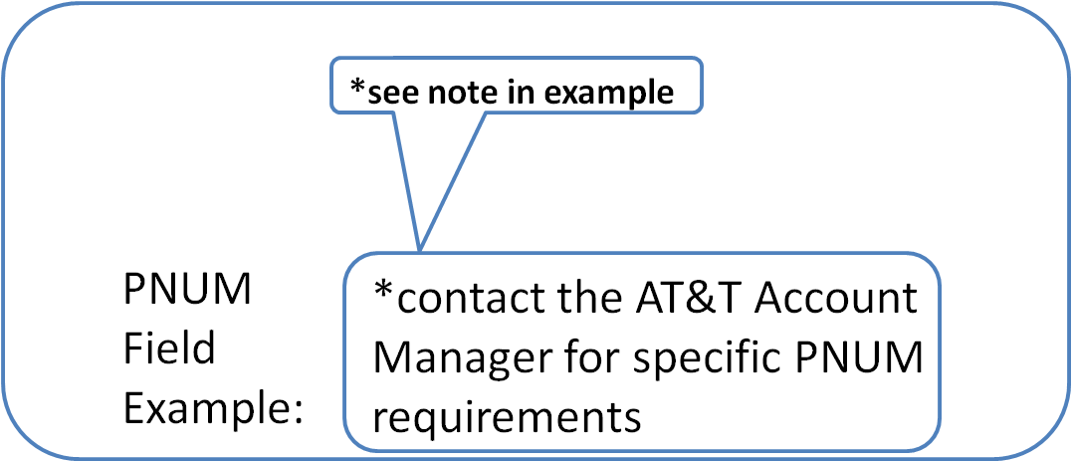
Figure 6: AT&T Southeast PNUM Field Example
6.2.3 PSD field: no longer used

6.2.4 ASR Example: Customer desires a term of 36 months with a PriceFlex contract

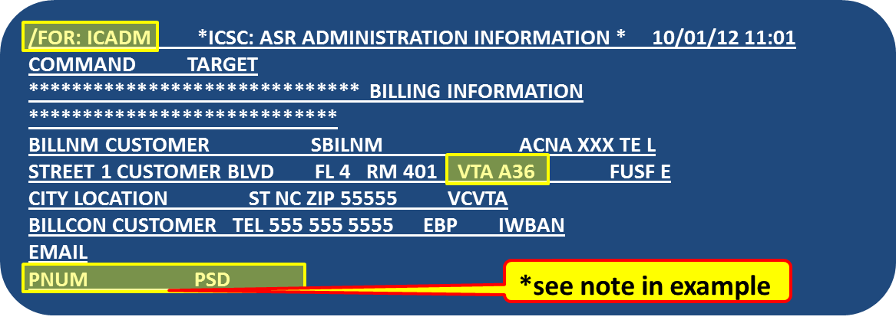
Figure 7: AT&T Southeast ASR Example

6.3 AT&T SOUTHWEST REGION (AR, KS, MO, TX, OK)
The VTA format is based on the type of product, the due date of the order, how many circuits are involved and the number of months for the payment plan.

6.3.1 VTA field: The format should be as follows: example = xxMM-DD-YY x xx
- VTA format needs spaces and dashes (-).
- New installations: The VTA date and DDD must match. If the ASR receives a supplement (supp) to change DDD, then VTA date must be updated as well.
- All DS3s require the VTA field to be populated.
- For DS1 service, populate the VTA field with the number of months desired; otherwise, leave the VTA field blank only if ordering service on a month-to-month basis.

- The two alpha characters that precede the due date of the plan, designate the type of service being ordered as follows:
  - DS1 = HT
    - Term plan options for HT (DS1)
      - 12 = 12 months
      - 24 = 24 months
      - 36 = 36 months
      - 60 = 60 months*
      - 84 = 84 months*
      - Month-to-Month (MTM) on a DS1, leave VTA field blank
  - DS3 = CT
    - Term plan options for CT (DS3)
      - 12 = 12 months
      - 36 = 36 months
      - 60 = 60 months*
      - 120 = 120 months (additional option for Megalink Custom Service) *

*NOTE: Effective September 2017, grandfathered Interstate Special Access DS1 and DS3 term payment and portability plans with terms longer than 3 years.

- The number date in the format (CT01-07-12 1 36), indicates the in-effect date of the payment plan.
- The number 1 in the format (CT01-07-12 1 36), indicates the number of circuits being requested on the plan. When “1” is populated, each circuit has a standalone payment plan.
  - For DS1, it should always show a “1”.
  - For DS3, select “1” unless ordering a 3, 6, or 12 volume option outlined in the tariff.
- The number 36 in the format (CT01-07-12 1 36, designates the number of months being requested.
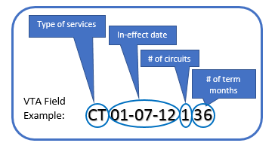
Figure 8: AT&T Southwest VTA Field Example
6.3.2 PNUM field: example = PF7341xxx (xxx = unique contract number)
- If PriceFlex does not apply, leave PNUM blank.

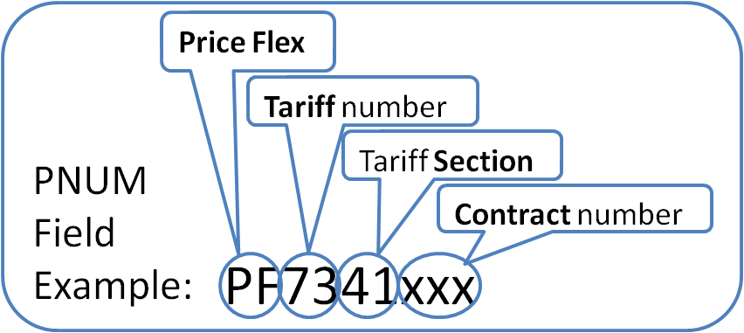
Figure 9: AT&T Southwest PNUM Field Example
6.3.3 PSD field: no longer used

6.3.4 ASR Example: Customer desires a DS3 with a term of 36 months with an in-effect date of 01-07-18 with a PriceFlex contract
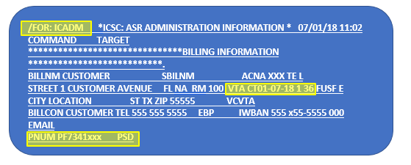
Figure 10: AT&T Southwest ASR Example

6.4 AT&T WEST REGION (NV & CA)
The VTA format is based on the type of product, the due date of the order, how many circuits are involved and the number of months for the payment plan.

6.4.1 VTA field: The format should be as follows: example = xxMM-DD-YY x xx
- VTA format needs spaces and dashes (-).
- New installations: The VTA date and DDD must match. If the ASR receives a supplement (supp) to change DDD, then VTA date must be updated as well.
- All DS3s require the VTA field to be populated.
- For DS1 service, populate the VTA field with the number of months desired; otherwise, leave the VTA field blank only if ordering service on a month-to-month basis.
- The two alpha characters that precede the due date of the plan, designate the type of service being ordered as follows:
  - DS1 = HT
    - Term plan options for HT (DS1)
      - 12 = 12 months
      - 24 = 24 months
      - 36 = 36 months
      - 60 = 60 months*
      - 84 = 84 months*
      - Month-to-Month (MTM) on a DS1, leave VTA field blank.
  - DS3 = FA
    - Term plan options for FA (DS3)
      - 12 = 12 months
      - 36 = 36 months
      - 60 = 60 months*

*NOTE: Effective September 2017, grandfathered Interstate Special Access DS1 and DS3 term payment and portability plans with terms longer than 3 years.

- The number date in the format (HT10-25-12 1 36), indicates the in-effect date of the payment plan.
- The number 1 in the format (HT10-25-12 1 36), indicates the number of circuits being requested on the plan. If “1” is populated, each circuit has a standalone payment plan.
  - For DS1, it should always show a “1”.
  - For DS3, select “1” unless ordering a DS3X3 (select 3) or DS3X12 (select 12) volume option outlined in the tariff.
- The number 36 in the format (HT10-25-12 1 36), designates the number of months being requested.
Figure 11: AT&T West VTA Field Example
6.4.2 PNUM field:
- example for CA = PF133xxx (xxx = unique contract number)
- example for NV = PF123xxx (xxx = unique contract number)
- If PriceFlex does not apply, leave PNUM blank.

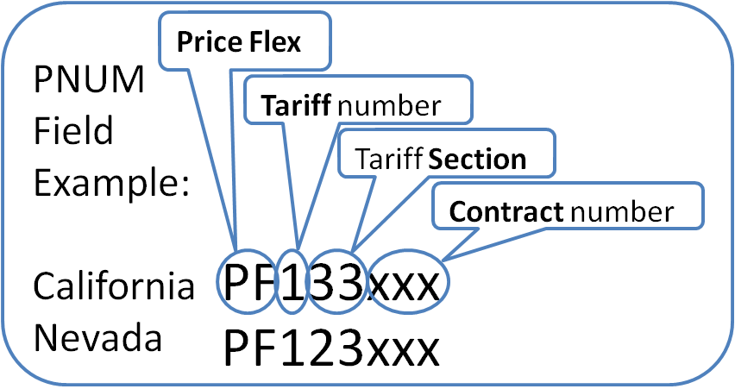
Figure 12: AT&T West PNUM Field Example
6.4.3 PSD field: no longer used

6.4.4 ASR Example: Customer desires a DS1 with a term of 36 months with an in-effect date of 10-25-12 with a PriceFlex contract.

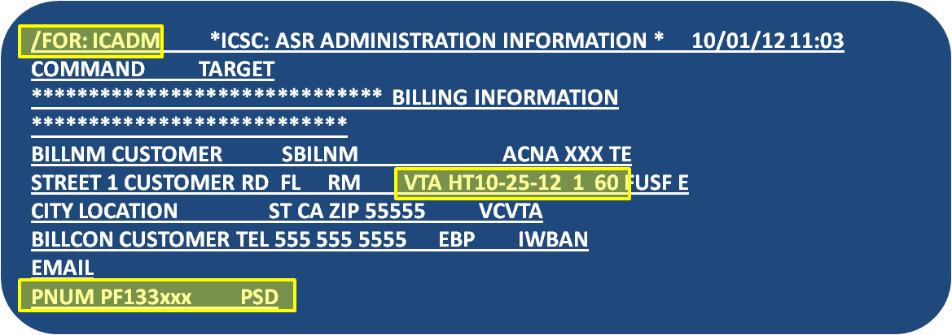
Figure 13: AT&T West ASR Example

7 AT&T VTA FORMAT GUIDE: ONE PAGE SUMMARY
Table 1: AT&T VTA Format Guide Summary
AT&T Region | VTA Field | Notes
Midwest  (IL, WI, OH, IN,MI) | The format is XX.  (xx = number of months) | In the VTA field on the ICADM screen, populate with the number of months being requested.  VTA field: The format is XX (xx = number of months).  • All DS3s require the VTA field to be populated  • For DS1 service, populate the VTA field with the number of months desired; otherwise, leave the VTA field blank only if ordering service on a month-to-month basis.  • Options for DS1 & DS3 are:*  o 12 = 12 months  o 24 = 24 months  o 36 = 36 months  o DS1 only: Month-to-Month (MTM), leave VTA field blank  o *If PNUM is populated, non-standard terms are allowed based on Price Flex contract.
Southeast  (TN, AL, KY, MS, LA, NC, SC, FL, GA) | The format is AXX or 1XX.  (xx = number of months)  (A = TPP only)  (1 = CSPP only)  *See explanation to right. | In the VTA field on the ICADM screen, populate the payment plan (1 or A) and the number of months being requested.  VTA field: The format should be as follows: example = A36.  • Populate the payment plan (1 or A) and the number of months being requested  o DS1:  -Transport Payment Plan (TPP) only:  --Axx (xx = the number of months from 12 to 36)  -Channel Service Payment Plan (CSPP) only:  --1xx (xx = the number of months from 24 to 36)  -TPP and CSPP:  --Axx (xx = the number of months from 24 to 36)  ----Populate CSPP in the ASR “Remarks” with 1xx (xx = the number of months from 24 to 72)—Matching number of months (Axx & 1xx)  -Month-to-Month (MTM), leave VTA field blank  o DS3:  -Axx (xx = the number of months from 12 to 36)  -Month-to-Month (MTM), leave VTA field blank
Southwest  (AR, KS, MO, TX, OK) | The format is:  xxMM-DD-YY x xx  *See explanation to right. | The VTA format is based on the type of product, the due date of the order, how many circuits are involved and the number of months for the payment plan.  VTA field: The format should be as follows: example = xxMM-DD-YY x xx  • VTA format needs spaces and dashes (-).  • New installations: The VTA date and DDD must match. If the ASR receives a supplement (supp) to change DDD, then VTA date must be updated as well.  • All DS3s require the VTA field to be populated  • For DS1 service, populate the VTA field with the number of months desired; otherwise, leave the VTA field blank only if ordering service on a month-to-month basis.  • The two alpha characters that precede the due date of the plan, designate the type of service being ordered as follows:  o DS1 = HT  • Term plan options for HT (DS1)  • 12, 24, or 36  • Month-to-Month (MTM) on a DS1, leave VTA field blank  o DS3 = CT  • Term plan options for CT (DS3)  • 12, or 36  • The number date in the format (CT01-07-12 1 36), indicates the in-effect date of the payment plan  • The number 1 in the format (CT01-07-12 1 36), indicates the number of circuits being requested on the plan. When “1” is populated, each circuit has a stand alone payment plan.  o For DS1, it should always show a “1”.  o For DS3, select “1” unless ordering a 3, 6, or 12 volume option outlined in the tariff.  • The number 36 in the format (CT01-07-12 1 36), designates the number of months being requested.
West  (NV & CA) | The format is:  xxMM-DD-YY x xx  *See explanation to right. | The VTA format is based on the type of product, the due date of the order, how many circuits are involved and the number of months for the payment plan.  VTA field: The format should be as follows: example = HT10-25-12 1 36.  • VTA format needs spaces and dashes (-).  • New installations: The VTA date and DDD must match. If the ASR receives a supplement (supp) to change DDD, then VTA date must be updated as well.  • All DS3s require the VTA field to be populated  • For DS1 service, populate the VTA field with the number of months desired; otherwise, leave the VTA field blank only if ordering service on a month-to-month basis.  • The two alpha characters that precede the due date of the plan, designate the type of service being ordered as follows:  o DS1 = HT  • Term plan options for HT (DS1)  • 12, 24, or 36,  • Month-to-Month (MTM) on a DS1, leave VTA field blank  o DS3 = FA  • Term plan options for FA (DS3)  • 12, or 36  • The number date in the format (HT10-25-12 1 36), indicates the in-effect date of the payment plan.  • The number 1 in the format (HT10-25-12 1 36), indicates the number of circuits being requested on the plan. When “1” is populated, each circuit has a stand alone payment plan.  o For DS1, it should always show a “1”.  o For DS3, select “1” unless ordering a DS3X3 (select 3) or DS3X12 (select 12) volume option outlined in the tariff.  • The number 36 in the format (HT10-25-12 1 36), designates the number of months being requested.

