SS7: AT&T SS7 Link Diversity Guidelines
for ICN Interconnection
Table of Contents
Introduction 2
LINK DIVERSITY 3
SS7 LINKS 3
LINK SET 3
COMBINED LINK SET 3
LINK TYPE DEFINITIONS 4
A-Link 4
A-Link Combined Link Set Diversity 5
B-Link 7
C-Link 8
D-Link 9
INTRA-BUILDING DIVERSITY 10
INTER-OFFICE DIVERSITY 10
GEOGRAPHIC FACILITY DIVERSITY: 11
CABLE SHEATH DIVERSITY: 11
CARRIER SYSTEM DIVERSITY: 11
INTER-OFFICE FACILITY PREFERENCE 11
MAINTAINING DIVERSITY DESIGN 13
RELATED DOCUMENTS 13
Acronyms 13
DOCUMENT SPECIFIC ACRONYMS 13

Introduction
The purpose of this document is to provide guidelines and procedures for achieving and maintaining recommended SS7 (Signaling System 7) Link Diversity for ICN (Interconnecting CCS Network) such as CLEC (Competitive Local Exchange Carrier) and IXC (Inter-Exchange Carrier) SS7 interconnection with the AT&T SS7 network.
For survivability, the link diversification process strives for minimal downtime and cost effectiveness. In accordance with the capital and expense funding that is made available, the highest degree of diversity that can be obtained shall be deployed. These guidelines are for “path forward” and do not imply immediate correction but correction(s) should be considered when opportunities exist or occur in the AT&T SS7 network due to growth, rearrangements, etc. The recommendations of the ICN Interconnection standard is to provide physical link set diversity and assure that one physical outage will not result in the loss of service between SS7 NEs (Network Elements). AT&T cannot provide this assurance if a common POP (Point of Presence) is not physically diverse. If a common POP exists for an ICN SS7 links then AT&T will strive to provide diversity at the earliest point within its SS7 network. When designing link diversity AT&T will use existing architecture and equipment within its network. If an ICN desires greater diversity either beyond GR-905-CORE guidelines or beyond existing AT&T Infrastructure, the ICN will provide a BFR (Bona Fide Request) to provide greater diversity.
The Common Channel Signaling (CCS) network is a separate overlay network used to transport signaling information between Signaling Points (SP), Service Signaling Points (SSP), Signaling Transfer Points (STP), Signaling End Points (SEP) and Service Control Points (SCP). This signaling information is packet switched communications protocol commonly referred to as SS7 protocol. SS7 protocol messages contain information from the most basic call connect and disconnect functions to sophisticated query and response transactions, i.e.. Caller ID, Calling Name, 8XX Data Base, between switching network and databases.
SS7 links for this document are 56KB/s point-to-point circuits. AT&T recommends ICN interconnection per GR-905-CORE, Section 6.1 “Interconnecting 56-kbps SS7 links shall be interfaced at a minimum DS1 (1.544Mbps) rate.” The use of a DS1 interface provides AT&T with digital testing and maintenance surveillance capabilities for the physical layer of the signaling link. Due to testing and maintenance that may be required on an individual 56-kbps SS7 link and its DS1, the DS1 should and may carry multiple 56-kbps signaling links, within diversity guidelines.

LINK DIVERSITY
Link diversity is a critical ingredient in Network Reliability and requires provisioning links in such a manner that a single element failure will not cause disruption of services, i.e. isolating a SS7 NE from it's STP. Because of the critical nature of SS7 links, physical, electrical, and architectural diversity criteria is necessary. AT&T SS7 link architectural criteria includes duplicated or paired STPs and SCPs for redundancy. Diversity requirements are designed to prevent a single network failure from isolating a SS7 NE from its mated STP pair. Entering the AT&T SS7 network at a single or common POP is considered a common point and does not meet AT&T SS7 link standards for physical, electrical, architectural criteria diversity or Telcordia GR-905-CORE guidelines. SBC will strive to provide physical and electrical diversity from the POP to the SBC STPs at the earliest point within its network. It is recommended an ICN avoid a common POP for its links entering the AT&T SS7 Network.

SS7 LINKS
The six types of SS7 links that may be used in a CCS network are A, B, C, D, E and F. Currently, AT&T only uses A, B, C and D links. Links are mated in sets and are duplicated according to their use and organized into “Link Sets” and “Combined Link Sets”. SS7 NEs are SCPs, SSPs and STPs. SSP are stored program control switching systems (SPCS) that have database access features.

LINK SET
Each link set contains one (1) to sixteen (16) links and will connect two SS7 NEs, i.e. a SP/SCP/SSP/STP to a STP.

COMBINED LINK SET
A combined link set consists of two link sets and will have a total of (2) two to (32) thirty-two links. Each SP/SCP/SSP will have two links sets, one link set to each STP in a mated pair. Two-way path diversity should be provided for combined links sets. If combined link sets enter the AT&T network at a common POP then AT&T will strive to provide two-way path diversity at the earliest point within its network.

LINK TYPE DEFINITIONS

A-Link
An A-Link connects SSPs and SCPs to a STP. A-links may be used to interconnect a AT&T STP pair with a CLEC or IXC SS7 SP when that company does not have a STP pair. If Path A and B meet SBC in a common POP then AT&T will strive to provide 2-way diversity at the earliest point within its network.

Figure 1.A-Link Diversity
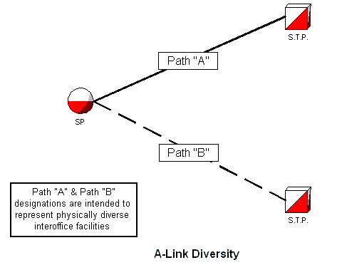

A-Link Combined Link Set Diversity
All combined “A-Link” Link Sets will meet two-way path diversity. A-Link link sets are provisioned in pairs called “Combined Link Sets”. Each SP will have at least one link installed to each of its two home STPs. The two link sets are considered to be a combined link set. If an A-Link link set is comprised of multiple links, two-way path diversity within the link set should be provided (Figures 2 and 3). Links within a combined link set may have a Common Point of Intersection (CPI). No single failure will isolate any SP from its home STP pair. If Path A and B meet AT&T in a common POP then AT&T will strive to provide two-way diversity at the earliest point within its network.

Figure 2.A-Link Combined Link Set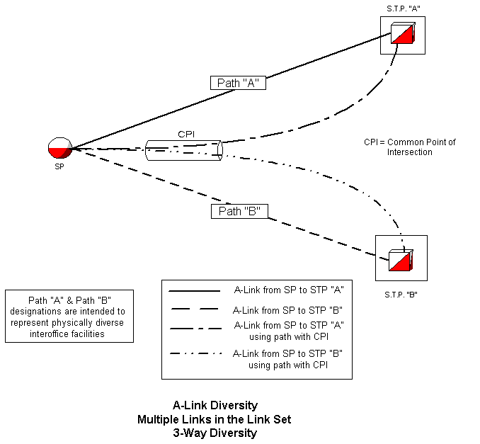

Figure 3.A-Link Crossover
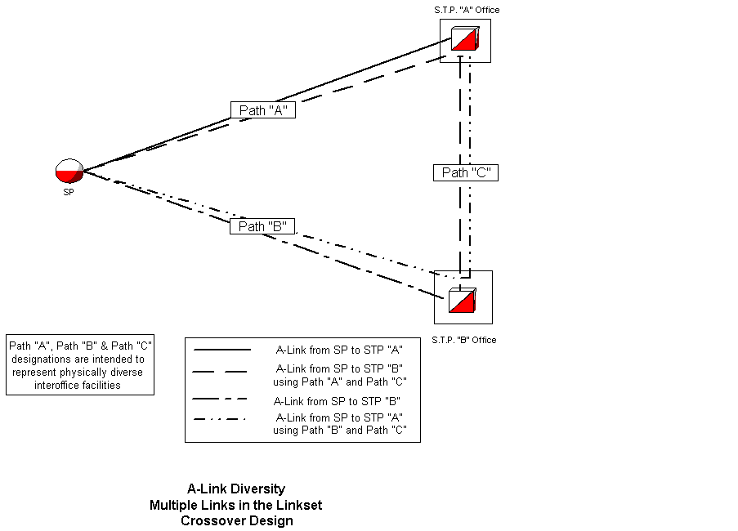

B-Link
B-Links will connect two different pairs of “mated STPs” at the hierarchical level in a configuration called a “link Quad”. B-link quad is made up of four (4) link sets with a minimum of one (1) link per link set.
All “B-Link” Quads will meet three-(3)way diversity.
No two failures will deny signaling capability between any two interconnecting STPs. 3-way diversity must be designed point-to-point, mated STP pair to mated STP pair. If a common POP exists between mated STP pairs, 3-way diversity may not be available within the SBC network. This is especially true if the POP between mated STP pairs is physically located within a AT&T STP location.

Figure 4.B-Link Quad
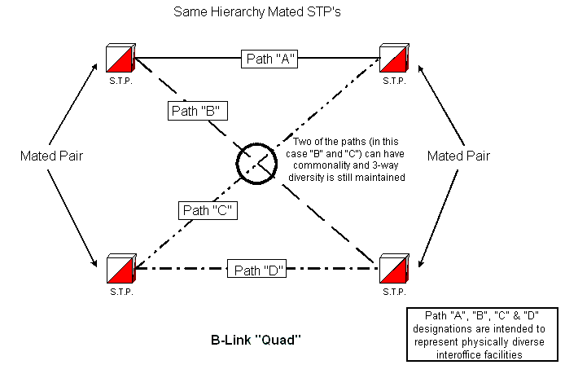

C-Link
STPs are paired in each Local Access Transport Area (LATA). A STP within a LATA is connected to it's mate STP via C-Links. C-Links are only between mated STPs and do not interconnect to ICN.
All “C-Link” link sets will meet two-(2)way diversity. No more that 50% of a C-Link link set will have a common single point of failure. No single failure will isolate a mated pair of STPs from each other.

Figure 5.C-Link
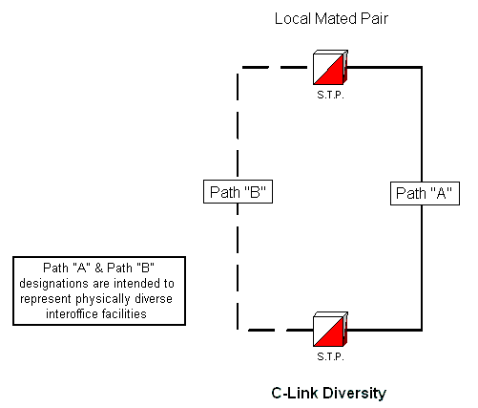

D-Link
D-links will connect a local STP pair to a regional STP pair. The difference in a D-Link quad and a B-Link quad is B-Links connect STPs at the same hierarchical level. D-Links connect STPs of different hierarchical levels, local to regional, via a link quad. ICN links are often referred to as D-Links.
All “D-Link” Quads will meet three(3)-way diversity.
No two failures will deny signaling capability between two interconnecting STPs. The same conditions for B-Links exist for D-Links as stated above.

Figure 6.D-Link Quad
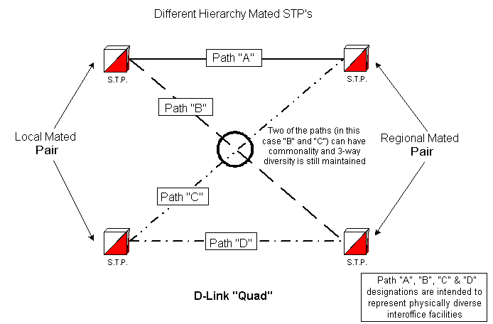

INTRA-BUILDING DIVERSITY
Intra-Building diversity is physical and electrical diversity within the “four walls” of a SP or STP location, the central office. AT&T will strive for Intra-Building Diversity from the POP to the connecting AT&T STP. If the POP is a common point of interface, SBC will strive to provide diversity at the earliest point within its network. A common POP will introduce diversity limitations to the overall link circuit design and will not meet Telcordia GR-905-CORE guidelines. When designing link diversity AT&T will use existing architecture and equipment. The minimum AT&T requirements for Intra-Building diversity are:
- Cabling of Intra-Building link paths: Each link path has physically separate routes.
- Power and fusing: Link components do not share power sources with another link in the same link set.
- Distributing Frames: Physical separation for jumpers, connector blocks and jumper routes must be maintained between link paths in the same link set. In addition connections should have special service protection and special markings as defined by OTC practice. If the ICN hands off multiple links at the DS0 level to a common point, SBC will strive to provide diversity from that point.
- Digital Cross-Connect Systems: Link paths should not share a common DCS, especially if in the same link set. If ICN links are provided with a single DS1 to a DCS, SBC will strive to provide diversity from that point.
- D4 Banks: Each path must be on a separate relay rack.
- Office Repeater Bays, DSX bays: Diverse link paths must not share a common relay rack.
- Synchronization: Components of diverse link paths shall derive synchronization from separate output cards in the office Building Integrated Timing Supply (BITS) system.
Basically, every critical portion of the SS7 network should be duplicated and separated within the building. Some exceptions may exist, such as:
- Building Entrances: Where there is a single facility entrance.
- Circuit Distribution Frames: Where there is a single Circuit Distribution frame, circuit cabling, connector blocks and equipment bays will be in different cable racks and bays/frames.
- Power Plants: In buildings that have single power plants. Distribution fuses (not the main discharge fuse) within a BDFB, etc., must be diverse loads and physically separated.
- IOF Single Thread Signaling Points” “Single Thread” offices that have only one IOF facility route. Each OTC should have plans and prioritization for eliminating single thread offices.

INTER-OFFICE DIVERSITY
Inter-Office Diversity is the physical and electrical diversity between two buildings and has three level of facility diversity. The order of priority is:

GEOGRAPHIC FACILITY DIVERSITY:
Requires associated diverse circuits route on inter-office cable/fiber facilities that are on geographically diverse paths. This includes avoiding common intermediate buildings. Routing circuits on SONET Rings may be considered as Geographic Facility Divers if criteria listed later in this document are met. Microwave radio should only be used for transporting SS7 links to meet Geographic Facility Diversity.

CABLE SHEATH DIVERSITY:
Requires associated diverse circuits routing on the same geographic route will be in separate cable sheaths.

CARRIER SYSTEM DIVERSITY:
Requires associated diverse circuits route on different carrier systems between two Central Offices. The route of these carrier systems does not have geographic or sheath diversity.
AT&T Facility Diversity is defined as Geographic Diversity.

INTER-OFFICE FACILITY PREFERENCE
Facilities with built-in protection switching, including Synchronous Optical Network (SONET) Rings constitute a single facility. Although SONET provides superior availability / survivability, it does not by itself constitute 2-way diversity. As new facilities are added an effort will be made to review the existing SS7 link facility paths to maximize the diversity across the facility paths now available. This effort will include non-SBC links. In order of preference, new facility choices are ranked below.:
- Diverse SONET Self-healing Rings (SHR)
- Diverse single SONET Ring and Asynchronous fiber system
- Diverse Asynchronous fiber systems
- Diverse combination of fiber (SONET or Asynchronous) and non-optical systems
- Diverse non-optical facilities
- Single Collapsed /Folded SONET Ring - Not recommended for all SS7 link paths from a SP
- Microwave Radio can only be used on one of the diverse routes and only as a last resort to meet Geographic Facility Diversity Criteria
The terms “Collapsed ring”and “Folded ring” may be used to describe a SONET ring architecture where both the primary and secondary (working/protect) fibers are in the same fiber path (cable sheath or fiber bundle). A collapsed/folded ring will fail if the fiber cable or bundle is cut, because of the lack of diverse fiber routing.
Routing circuits on SONET Rings may be considered geographic facility diversity, though not considered 100% survivable, due to the possibility of a SONET node failure.

MAINTAINING DIVERSITY DESIGN
The responsibility for auditing SS7 diversity will be left to the discretion of each OTC. In AIT, SNET and SWBT it is in Network Operations and in PB it is the local IOF Planning. Audits may be database (TIRKS), Office Records and Physical Reviews as required.

RELATED DOCUMENTS
Other Documents: Telcordia GR-905-CORE - Common Channel Signaling Network Interface Specification (CCSNIS) Supporting Network Interconnection, Message Transfer Part (MTP), and Integrated Services Digital Network User Part (ISDNUP)

Acronyms

DOCUMENT SPECIFIC ACRONYMS
This section lists acronyms that are used in this document only.
APEx - Advanced Publishing Express
BDFB - Battery Distributing Fuse Board
BFR - Bona Fide Request
CCS - Common Channel Signaling
CLEC - Competitive Local Exchange Carrier
CPI - Common Point of Interface
DCS - Digital Cross Connect System
ICN - Interconnecting CCS Network
IOF - Interoffice Facility
IXC - Inter-Exchange Carrier
NE - Network Element
OTC - Operating Telephone Company (AIT, PB, NB, SNET, SWBT)
POP - Point of Presence
SCP - Service Control Point
SHR - Self Healing Ring
SONET - Synchronous Optical Network
SP - Signaling Point
SPCS - Stored Program Control System
SS7 - Signaling System 7
SS7 NE - SS7 Network Element (SCP, SP, SSP, STP)
SSP - Service Switching Point (usually an end office switch)
STP - Signaling Transfer Point

